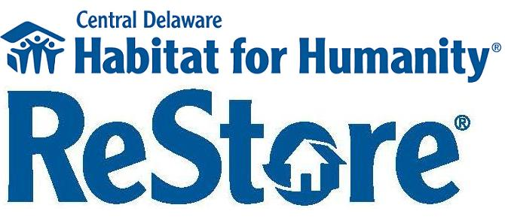

Position Title: ReStore Associate

Reports To: ReStore Manager

Time Commitment: Part-time, non exempt, hourly

Summary:

* CDHFH ReStore is looking for a store associate willing to work a flexible schedule Tuesday through Saturday approximately 20-25 hours per week. This position is a hands-on-job which requires a candidate willing to take on a wide array of responsibilities. The position includes: cash register operations, customer service, merchandising, pricing, staging, store house keeping, organization, and assisting the ReStore staff.

Specific Responsibilities:

* Operate the cash register by processing cash, credit, debit and checks.
* Assist in balancing the register on a daily basis
* Greet and be available for customers
* Communicate all sales issues and problems to the ReStore Manager
* Keep a revolving merchandise display and up-to-date pricing
* Oversee volunteers as needed
* Sorting and stage incoming donations; assisting the receiving/warehouse associate, as necessary
* Help maintain an orderly and clean showroom area; including the grounds
* Other duties as assigned by ReStore Manager

Work Schedule:

* Requires flexible schedule Tuesday through Saturday
* Occasionally varied schedule to support the needs of the ReStore

Physical Job Requirements:

* Ability to move throughout all areas of the store.
* Able to lift (properly) items up to and exceeding 50 pounds with reasonable assistance when needed
* Stand and/or sit continuously to perform job functions
* Physically able to stand, bend, stoop, kneel, reach, twist, lift, push, pull, climb, balance, crouch, handle and move items weighing up to 50 pounds without assistance
* Ability to work in a warehouse environment with variable temperatures

Qualifications:

* Requires a high school diploma or equivalent.
* Ability to apply basic mathematical concepts such as adding, subtracting, multiplying, dividing and knowledge of weights and measures
* Able to handle various sums of money; including but not limited to collecting and making change
* Able to read, write and communicate using English language
* Knowledge of CDHFH’ s mission, purpose, goals and the role of every employee in achieving each of them
* Able to operate store equipment (such as copier, fax, adding machine, computer).
* Have a basic knowledge of the internet
* Ability to handle customers situations with courteous, grace and composure

TO APPLY: Please send a cover letter and resume to [restore@centraldelawarehabitat.org](mailto:restore@centraldelawarehabitat.org) or drop off at 544 Webbs Lane, Dover, DE. NO PHONE CALLS PLEASE